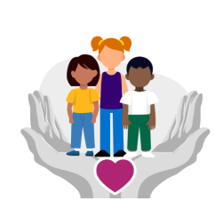
Child Friendly Child Protection Policy
Safeguarding means that school staff should:
- provide help and support to meet the needs of children as soon as problems emerge
  - protect children from maltreatment, whether that is within or outside the home, including online
- prevent the impairment of children’s mental and physical health or development
  - ensure that children grow up in circumstances consistent with the provision of safe and effective care
  - take action to enable all children to have the best outcomes

How we will protect you:
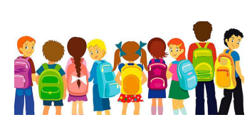
● We provide a safe and secure environment for you to learn in and progress.
● We help to ensure that you remain safe, at home as well as at school.
● We think it is important for you to know where to get help if you are worried or unhappy about something.

Any member of staff will help you. We also have the school’s safeguarding team who can help you too:
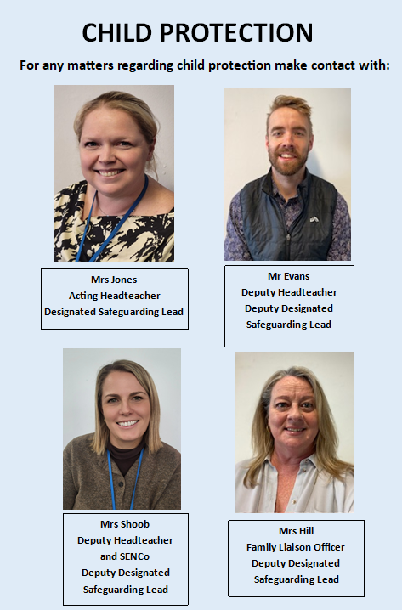

If you need to talk - we will listen.
You can talk to any adult within the school as we are all responsible for making sure you are safe and well cared for. Most of the time your worries will be sorted out really quickly but sometimes staff need to also ask the Safeguarding Leaders to support you too.
What happens next?
A member of the safeguarding team will deal with your concerns as quickly as possible. There may be times when they may need to contact other agencies in order to get you the support you need.
Tips for keeping yourself safe:
● Bullying – If you think a pupil or a grown up is bullying you or someone you know you must tell your teacher or someone you can trust as soon as you can. It will not stop unless you do.
● Saying things to you which make you feel uncomfortable or upset – If a student or a grown up says something to you, or you hear something that you do not like or that upsets you, you must tell your teacher or someone you can trust.
● Touching you – Your body belongs to you and not to anyone else. This means all of your body. If someone touches you on a part of your body like your bottom, chest or anywhere else you do not like, it is not ok. You must tell your parents/carers, a teacher or someone you can trust as soon as you can.
● Hitting, punching or physically hurting you – If a pupil or a grown up hits you, punches or hurts you in any way, you must tell your teacher or someone you can trust as soon as you can.
● Secrets – Secrets such as surprise parties are fun, but some secrets are not good and should never be kept.
● Presents – Presents are a good thing to get, but you should not take a present from anyone without checking with your parents/carers first. Most of the time it will be ok, but sometimes people try to trick children into doing something by giving them presents (like sweets, money, phones, cigarettes or drugs and alcohol) This is sometimes called a bribe. If it does not seem right, tell someone as soon as you can.
● On the computer or your phone - Computers and mobile phones help us all to share things and talk to our friends or family, but they can also make it easier for bullies and other people that want to hurt you to get close to you. It is important to know how to keep yourself safe on your computer, your phone and on websites.
● Sandgate Primary School has a Child Protection policy, which is there to protect you. If you are unhappy with any comments or photographs you have seen on your computer or mobile please speak to a trusted adult. If you have been contacted by someone you do not know and it has made you feel uncomfortable you can contact CEOP and make a report. Please ask an adult to help you if you can.



